# Test Generátorov

## Generátor 1 – Exponenciálne rozdelenie - 300

Prúd zákazníkov prichádzajúcich do autoservisu je poissonovsky prúd s intenzitou z = 12 zákazníkov za hodinu. Modelujem to exponenciálnym rozdelením 300 s. Každých 300 s vygeneruje nového zákazníka.

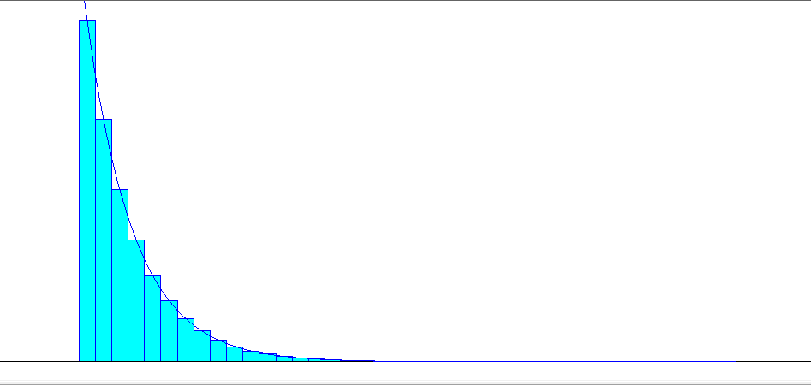

Distribution Summary

Distribution: Exponential

Expression: EXPO(300)

Square Error: 0.000001

Chi Square Test

Number of intervals = 32

Degrees of freedom = 30

Test Statistic = 33

Corresponding p-value = 0.335

Data Summary

Number of Data Points = 1000000

Min Data Value = 0.000352

Max Data Value = 4.12e+003

Sample Mean = 300

Sample Std Dev = 299

Histogram Summary

Histogram Range = 0 to 4.12e+003

Number of Intervals = 40

## Generátor 2 – Empirické rozdelenie – 1 - 6

Pravdepodobnosti počtu opráv, ktoré bude zákazník požadovať

Počet opráv: 1 2 3 4 5 6

Pravdepodobnosť 0.4 0.15 0.14 0.12 0.1 0.09

Kumulatívne 0,4 0,55 0,69 0,81 0,91 1

Kumulatívne:

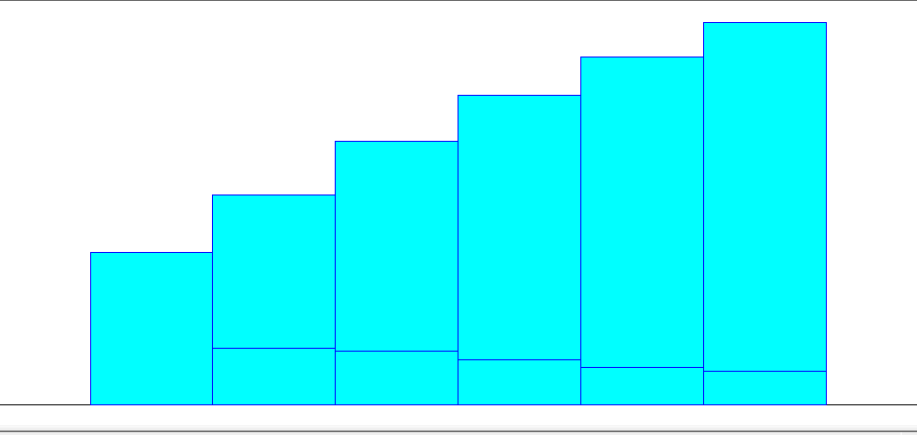

Distribution Summary

Distribution: Empirical

Expression: CONT or DISC (0.000, 0.500,

0.400, 1.500,

0.550, 2.500,

0.690, 3.500,

0.810, 4.500,

0.910, 5.500,

0.910, 6.500)

Data Summary

Number of Data Points = 1000000

Min Data Value = 1

Max Data Value = 6

Sample Mean = 2.64

Sample Std Dev = 1.72

Histogram Summary

Histogram Range = 0.5 to 6.5

Number of Intervals = 6

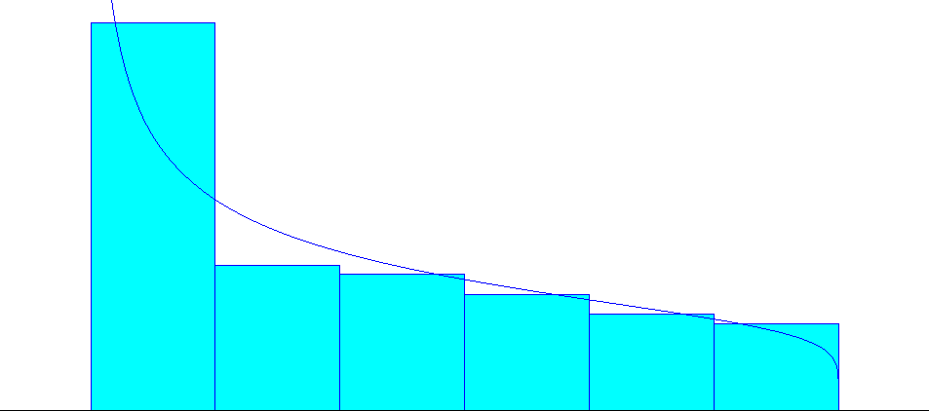

Distribution Summary

Distribution: Beta

Expression: 0.5 + 6 * BETA(0.643, 1.16)

Square Error: 0.002490

Chi Square Test

Number of intervals = 6

Degrees of freedom = 3

Test Statistic = 1.19e+004

Corresponding p-value < 0.005

Data Summary

Number of Data Points = 1000000

Min Data Value = 1

Max Data Value = 6

Sample Mean = 2.64

Sample Std Dev = 1.72

Histogram Summary

Histogram Range = 0.5 to 6.5

Number of Intervals = 6

## Generátor 3 –Normálne rozdelenie – 190, 120

Čas potrebný na prevzatie objednávky od zákazníka o = 190 s +- 120 s .

NORM(190, 120)

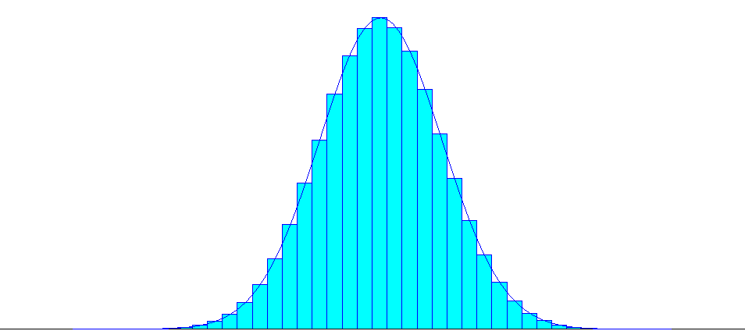

Distribution Summary

Distribution: Normal

Expression: NORM(190, 10.9)

Square Error: 0.000001

Chi Square Test

Number of intervals = 35

Degrees of freedom = 32

Test Statistic = 28.6

Corresponding p-value = 0.637

Data Summary

Number of Data Points = 1000000

Min Data Value = 135

Max Data Value = 241

Sample Mean = 190

Sample Std Dev = 10.9

Histogram Summary

Histogram Range = 135 to 242

Number of Intervals = 40

## Generátor 4 – Normálne rozdelenie – 120, 40

Čas potrebný na prevzatie auta od zákazníka p = 120s +- 40 s

NORM (120, 40)

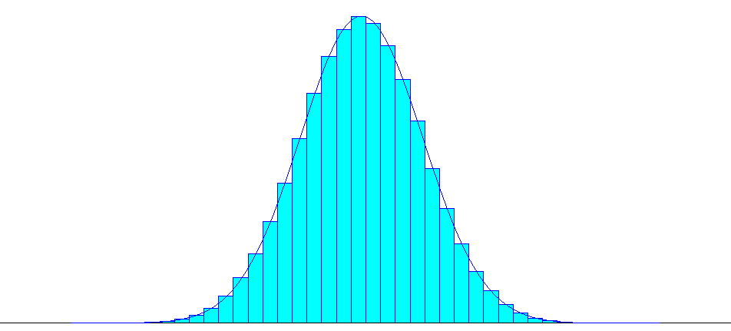

Distribution Summary

Distribution: Normal

Expression: NORM(120, 6.33)

Square Error: 0.000001

Chi Square Test

Number of intervals = 36

Degrees of freedom = 33

Test Statistic = 32.6

Corresponding p-value = 0.491

Data Summary

Number of Data Points = 1000000

Min Data Value = 91

Max Data Value = 150

Sample Mean = 120

Sample Std Dev = 6.33

Histogram Summary

Histogram Range = 90 to 151

Number of Intervals = 40

## Generátor 5 – Trojuholníkové rozdelenie – 120, 540, 240

Preparkovanie auta z parkoviska do dielne alebo naspäť sa riadi

Trojuholníkovým rozdelením s parametrami

min = 120 s, max 540, a modus = 240 s

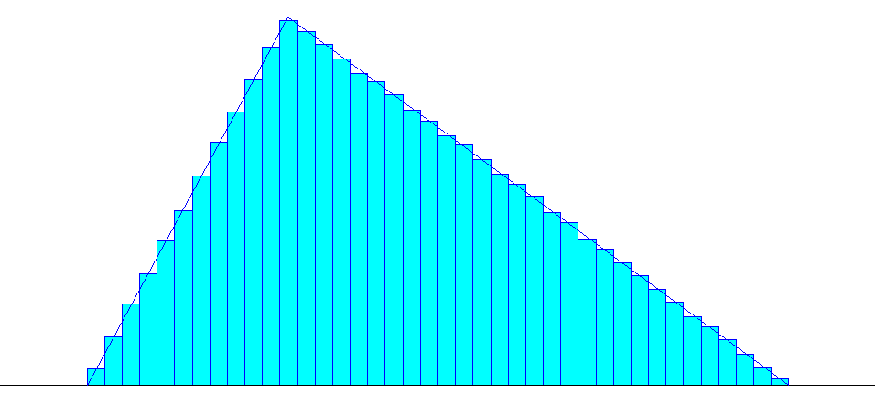

Distribution Summary

Distribution: Triangular

Expression: TRIA(120, 240, 540)

Square Error: 0.000001

Chi Square Test

Number of intervals = 40

Degrees of freedom = 38

Test Statistic = 52.9

Corresponding p-value = 0.0562

Data Summary

Number of Data Points = 1000000

Min Data Value = 120

Max Data Value = 540

Sample Mean = 300

Sample Std Dev = 88.3

Histogram Summary

Histogram Range = 120 to 540

Number of Intervals = 40

## Generátor 6 – Normálne rozdelenie – 190, 67

Prevzatie opraveného auta trvá s = 190 s +- 67s

NORM (190, 67)

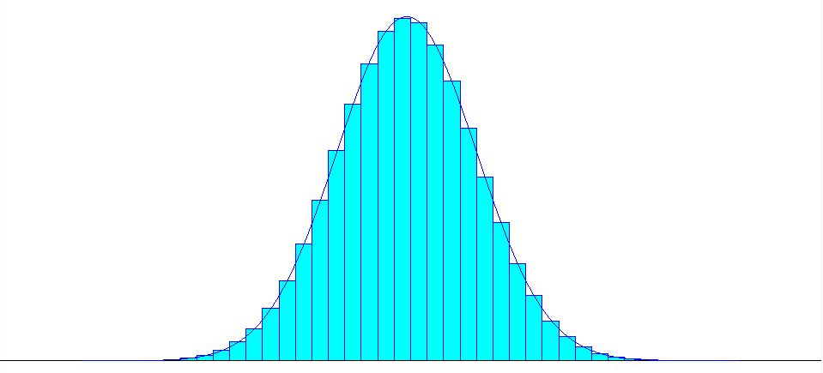

Distribution Summary

Distribution: Normal

Expression: NORM(190, 8.18)

Square Error: 0.000001

Chi Square Test

Number of intervals = 37

Degrees of freedom = 34

Test Statistic = 45

Corresponding p-value = 0.0984

Data Summary

Number of Data Points = 1000000

Min Data Value = 152

Max Data Value = 228

Sample Mean = 190

Sample Std Dev = 8.18

Histogram Summary

Histogram Range = 152 to 229

Number of Intervals = 40

## Generátor 7 – Diskrétne rovnomerné rozdelenie – 2, 20

Jednoduchá oprava - trvanie v minútach

Diskrétne rovnomerne = Tmin = 2, Tmax = 20

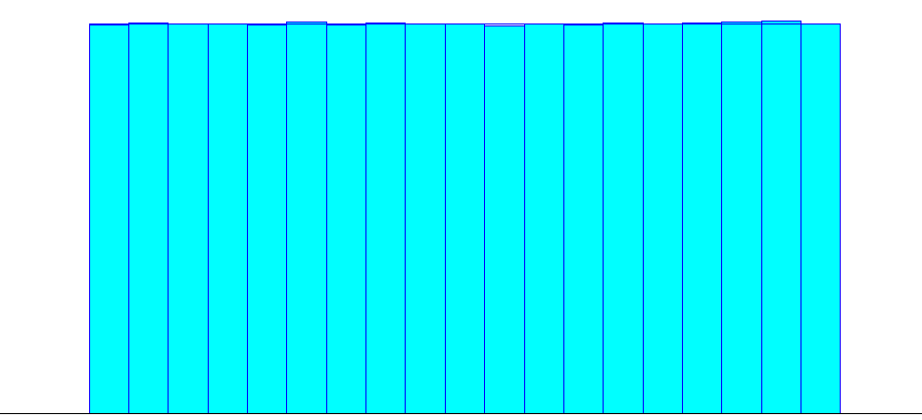

Distribution Summary

Distribution: Uniform

Expression: UNIF(1.5, 20.5)

Square Error: 0.000001

Chi Square Test

Number of intervals = 19

Degrees of freedom = 18

Test Statistic = 23.9

Corresponding p-value = 0.171

Data Summary

Number of Data Points = 1000000

Min Data Value = 2

Max Data Value = 20

Sample Mean = 11

Sample Std Dev = 5.48

Histogram Summary

Histogram Range = 1.5 to 20.5

Number of Intervals = 19

## Generátor 8 – Diskrétne empirické rozdelenie

Stredne ťažká oprava - trvanie v sekundách

T: 10 - 40 41– 61 62 – 100

p: 0.1 0.6 0.3

k: 0,1 0,7 1

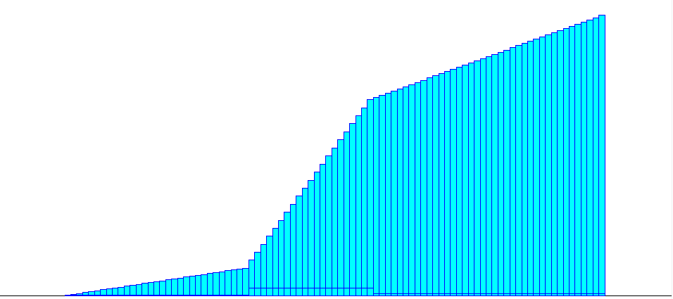

Distribution Summary

Distribution: Empirical

Expression: CONT or DISC (0.000, 9.500,

0.003, 10.500,

0.006, 11.500,

0.010, 12.500,

0.013, 13.500,

0.016, 14.500,

0.019, 15.500,

0.023, 16.500,

0.026, 17.500,

0.029, 18.500,

0.032, 19.500,

0.036, 20.500,

0.039, 21.500,

0.042, 22.500,

0.045, 23.500,

0.049, 24.500,

0.052, 25.500,

0.055, 26.500,

0.058, 27.500,

0.061, 28.500,

0.065, 29.500,

0.068, 30.500,

0.071, 31.500,

0.074, 32.500,

0.078, 33.500,

0.081, 34.500,

0.084, 35.500,

0.087, 36.500,

0.090, 37.500,

0.094, 38.500,

0.097, 39.500,

**0.100, 40.500,**

0.128, 41.500,

0.157, 42.500,

0.185, 43.500,

0.214, 44.500,

0.243, 45.500,

0.271, 46.500,

0.299, 47.500,

0.328, 48.500,

0.356, 49.500,

0.385, 50.500,

0.413, 51.500,

0.442, 52.500,

0.470, 53.500,

0.499, 54.500,

0.528, 55.500,

0.557, 56.500,

0.585, 57.500,

0.614, 58.500,

0.643, 59.500,

0.671, 60.500,

**0.700, 61.500,**

0.708, 62.500,

0.715, 63.500,

0.723, 64.500,

0.731, 65.500,

0.738, 66.500,

0.746, 67.500,

0.754, 68.500,

0.762, 69.500,

0.769, 70.500,

0.777, 71.500,

0.785, 72.500,

0.793, 73.500,

0.800, 74.500,

0.808, 75.500,

0.816, 76.500,

0.824, 77.500,

0.831, 78.500,

0.839, 79.500,

0.846, 80.500,

0.854, 81.500,

0.862, 82.500,

0.869, 83.500,

0.877, 84.500,

0.885, 85.500,

0.892, 86.500,

0.900, 87.500,

0.908, 88.500,

0.916, 89.500,

0.923, 90.500,

0.931, 91.500,

0.939, 92.500,

0.946, 93.500,

0.954, 94.500,

0.962, 95.500,

0.969, 96.500,

0.977, 97.500,

0.985, 98.500,

0.992, 99.500,

0.992, 100.500)

Data Summary

Number of Data Points = 1000000

Min Data Value = 10

Max Data Value = 100

Sample Mean = 57.4

Sample Std Dev = 19.1

Histogram Summary

Histogram Range = 9.5 to 101

Number of Intervals = 91

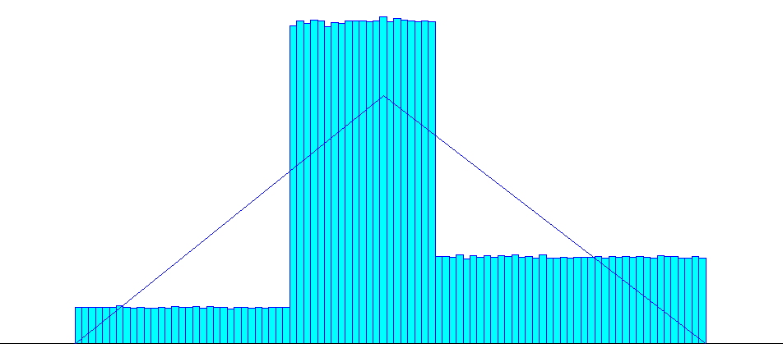

Distribution Summary

Distribution: Triangular

Expression: TRIA(9.5, 54, 101)

Square Error: 0.004304

Chi Square Test

Number of intervals = 91

Degrees of freedom = 89

Test Statistic = 7.13e+005

Corresponding p-value < 0.005

Data Summary

Number of Data Points = 1000000

Min Data Value = 10

Max Data Value = 100

Sample Mean = 57.4

Sample Std Dev = 19.1

Histogram Summary

Histogram Range = 9.5 to 101

Number of Intervals = 91

## Generátor 9 – diskrétne rozdelenie

Zložitá oprava

diskrétne rovnomerne Tmin = 120, Tmax = 260

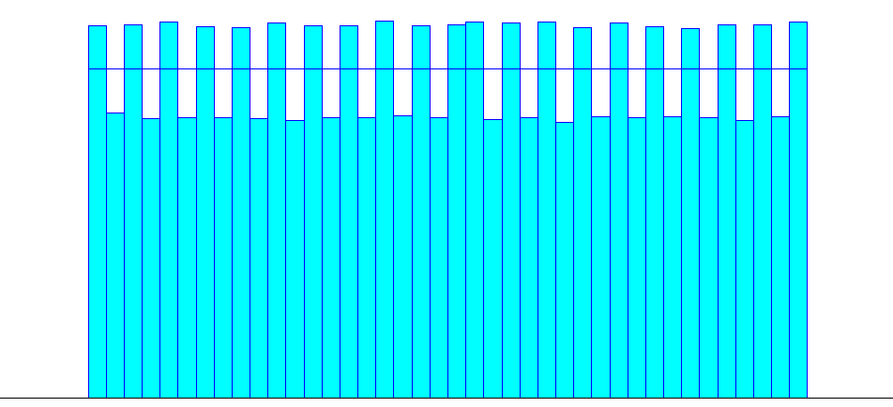

Distribution Summary

Distribution: Uniform

Expression: UNIF(120, 260)

Square Error: 0.000498

Chi Square Test

Number of intervals = 40

Degrees of freedom = 39

Test Statistic = 1.99e+004

Corresponding p-value < 0.005

Data Summary

Number of Data Points = 1000000

Min Data Value = 120

Max Data Value = 260

Sample Mean = 190

Sample Std Dev = 40.7

Histogram Summary

Histogram Range = 120 to 260

Number of Intervals = 40

## Generátor 10 – empirické rozdelenie

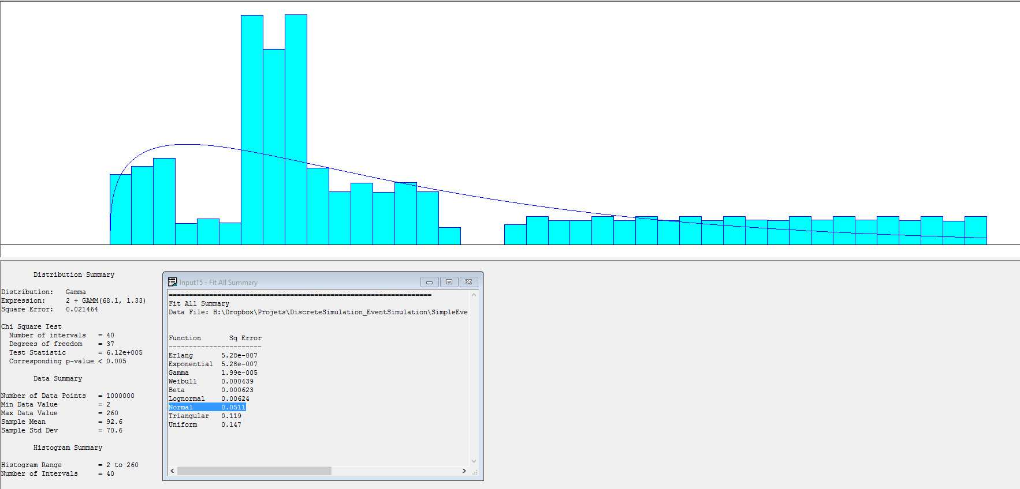

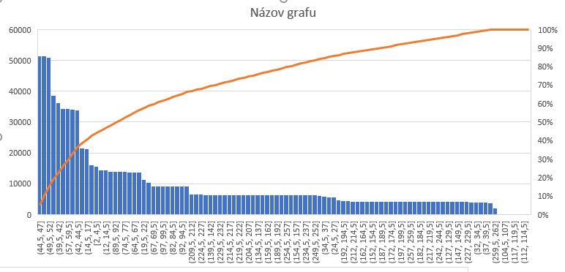

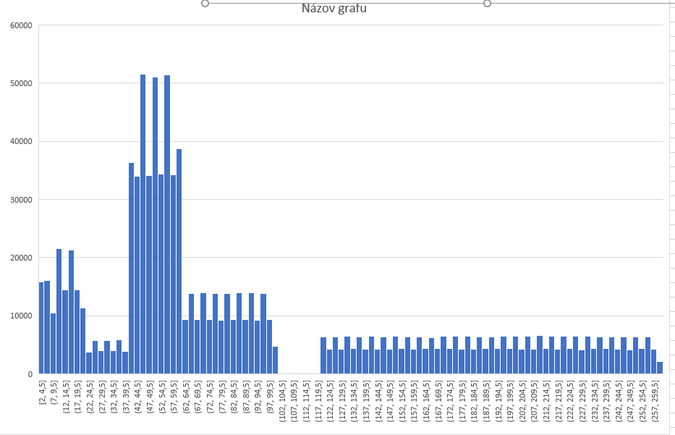

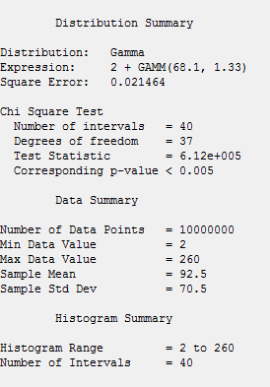 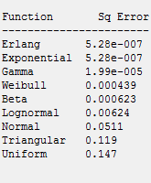

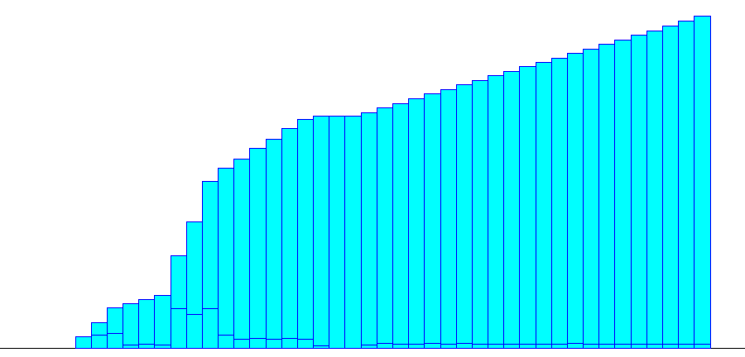

Distribution Summary

Distribution: Empirical

Expression: CONT or DISC (0.000, 1.999,

0.037, 8.449,

0.078, 14.899,

0.123, 21.349,

0.135, 27.799,

0.149, 34.249,

0.160, 40.699,

0.280, 47.149,

0.382, 53.599,

0.503, 60.049,

0.543, 66.499,

0.571, 72.950,

0.603, 79.400,

0.631, 85.850,

0.663, 92.300,

0.691, 98.750,

0.700, 105.200,

0.700, 111.650,

0.700, 118.100,

0.711, 124.550,

0.726, 131.000,

0.739, 137.450,

0.752, 143.900,

0.767, 150.350,

0.779, 156.800,

0.794, 163.250,

0.807, 169.700,

0.822, 176.150,

0.834, 182.600,

0.849, 189.050,

0.862, 195.501,

0.875, 201.951,

0.890, 208.401,

0.902, 214.851,

0.917, 221.301,

0.930, 227.751,

0.945, 234.201,

0.958, 240.651,

0.972, 247.101,

0.985, 253.551,

0.985, 260.001)

Data Summary

Number of Data Points = 1000000

Min Data Value = 2

Max Data Value = 260

Sample Mean = 92.5

Sample Std Dev = 70.5

Histogram Summary

Histogram Range = 2 to 260

Number of Intervals = 40

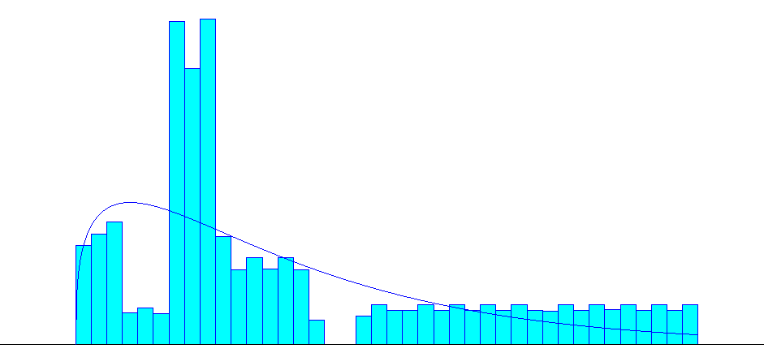

Distribution Summary

Distribution: Gamma

Expression: 2 + GAMM(68, 1.33)

Square Error: 0.021498

Chi Square Test

Number of intervals = 40

Degrees of freedom = 37

Test Statistic = 6.12e+005

Corresponding p-value < 0.005

Data Summary

Number of Data Points = 1000000

Min Data Value = 2

Max Data Value = 260

Sample Mean = 92.5

Sample Std Dev = 70.5

Histogram Summary

Histogram Range = 2 to 260

Number of Intervals = 40